**Experiment 2.1**

**Student Name: Sahul Kumar Parida UID: 20BCS4919**

**Branch: CSE Section/Group: WM904/B**

**Semester: 5th Date of Performance: 13/09/22**

**Subject Name: Machine Learning Lab Subject Code: CSP-317**

**1. Aim/Overview of the practical:**

Implement Support Vector Machine on any data set and analyze the accuracy with Logistic regression.

# 2. Task to be done:

i) To implement SVM on any standard dataset.

ii) To analyze the accuracy with Logistic Regression.

# 3. Apparatus/Simulator used:

* Jupyter Notebook/Google Collab
* pandas
* matplotlib

**4. Code and Output:**

insurance_data.csv dataset

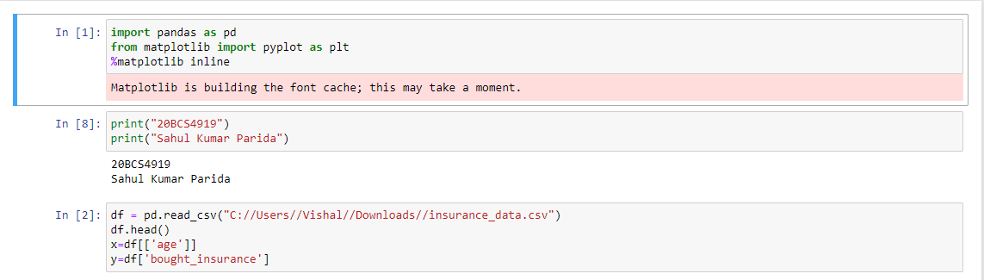

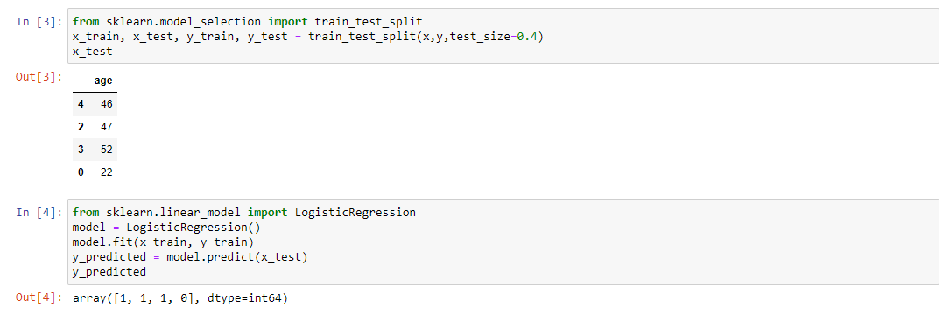

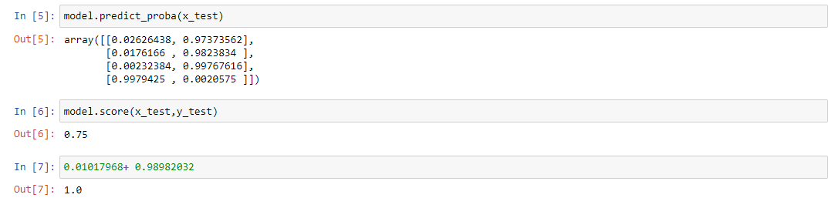

appleorange.csv dataset

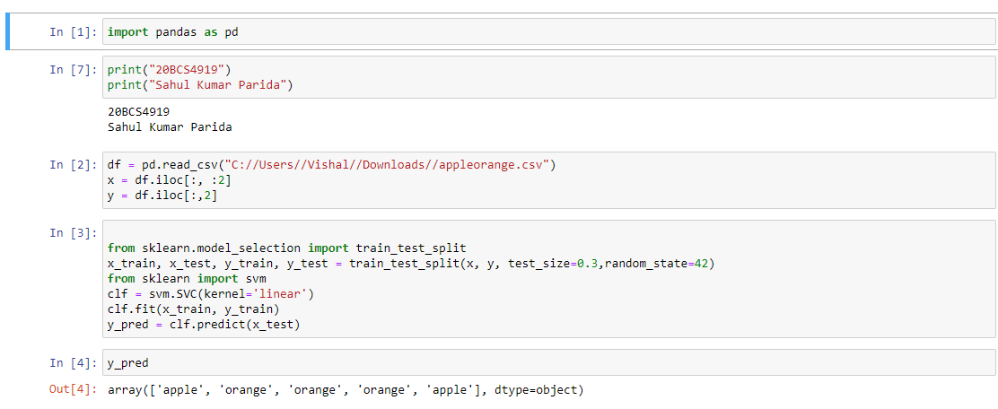

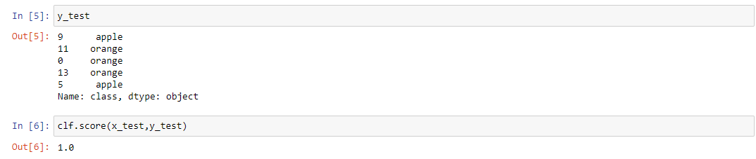

**Learning outcomes (What I have learnt):**

1. Understanding of Support Vector Machine and Logistic Regression.
2. Able to analyze different datasets with the help of python libraries.
3. Learning about different library/packages of python.
4. Learning about the different methods, that are needed to analyze the given dataset.
5. Learning about different Machine Learning Functions.